Name – Aditya Sharma

Batch – B1

Sap id -500122015

Assignment -1

OOPS lab

2. Install Latest JDK on Windows and Verify the Java Environment

Since you’ve installed the JDK using the installer version, follow these steps to verify the setup.

1. Confirm Installation:
   * After installing the JDK, ensure the installer successfully added the JDK to your system.
2. Verify Installation in Command Prompt:
   * Open the Command Prompt (press Windows + R, type cmd, and hit Enter).
   * Check the installed Java version by typing:
   * java -version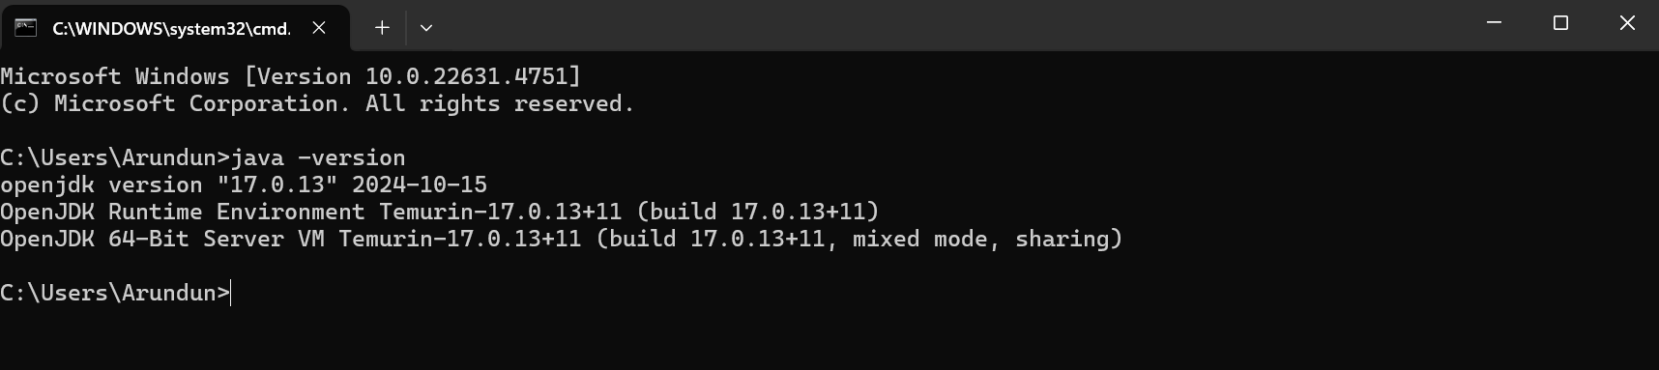
3. Verify the Java Compiler (JDK):
   * Type the following command to confirm the Java Compiler (javac) is working:

